**DISPLACED INFO:**

The general first-order differential equation is represented as:

$$\frac{∂y\left(t\right)}{∂t}=f\left(t,y\right), t∈\left[a,b\right]$$

The general first-order differential equation is represented as:

$$y_{t}\left(t\right)=A+\left(t-a\right)z\left(t\right)$$

The error used to train the KAN model can be defined as such: $$E\left(w\right)=\frac{1}{2}{\left(\frac{∂y_{t}\left(t\right)}{∂t}-f\left(t,y\right)\right)}^{2}$$

Finally, the new weights can be calculated using the error defined previously:

$$w_{k}=w_{k-1}-η\frac{∂E\left(w\right)}{∂w_{k}}$$

**Abstract**

**WRITE THIS WHEN THE WORK IS DONE**

1. **Introduction**

Ordinary differential equations (ODEs) serve as fundamental instruments in the mathematical modeling and analytical study of numerous scientific and engineering systems. They naturally emerge in diverse applications, including but not limited to fluid dynamics, chemical reaction kinetics, population dynamics, and structural analysis [1-5, 13]. The inherent complexity of ODEs presents significant challenges in their solution, as numerous cases do not yield closed-form solutions, necessitating the utilization of numerical or approximation techniques. Established numerical methodologies, including the Runge-Kutta technique, finite difference approach, and shooting method, have historically been employed to tackle these challenges. However, their drawbacks—such as considerable computational demands and the inability to produce closed-form solutions—have motivated the investigation of alternative strategies for ODE resolution [1-3, 5, 12, 13].

The introduction of Artificial Neural Networks (ANNs) has facilitated novel methodologies for the numerical resolution of ODEs by recontextualizing the problem as an optimization framework. Preliminary investigations have demonstrated the efficacy of multilayer perceptrons (MLPs) in approximating solutions to both initial value problems (IVPs) and boundary value problems (BVPs).

These neural network-based approaches present significant advantages over traditional numerical methods. Specifically, ANNs can produce analytic solutions that eliminate the necessity for interpolation across discretized computational intervals, thus providing enhanced adaptability in addressing both IVPs and BVPs [1, 3, 6, 7, 11, 13 -17]. However, early iterations of ANN models encountered impediments, including a pronounced vulnerability to convergence at local minima and suboptimal rates of convergence [1].

In order to address the limitations of traditional ANNs, advanced architectures have been introduced, including Radial Basis Function Neural Networks (RBFNNs) [2, 3, 12] and Wavelet Neural Networks (WNNs) [1] These specialized architectures exhibit accelerated convergence rates and improved precision in the approximation of solutions for intricate differential equations. Notably, WNNs have attracted considerable interest due to their localized activation functions, which facilitate compact network designs and expedite the learning process while maintaining the universal approximation capability characteristic of neural networks[1]. Furthermore, the implementation of sophisticated training methodologies, such as Extreme Learning Machines (ELM) and metaheuristic optimization techniques, including Particle Swarm Optimization (PSO), has substantially enhanced both the efficiency and accuracy of these neural network models [1, 2, 4, 5, 14].

Building upon this foundational principle, the Kolmogorov-Arnold Network (KAN) architecture presents a novel and robust framework specifically engineered for function approximation, demonstrating considerable potential for addressing ODEs. The KAN model is fundamentally grounded in the Kolmogorov-Arnold representation theorem, which asserts that any continuous multivariate function can be expressed as a finite sum of univariate functions [6-8, 13, 15-18]. This intrinsic universality renders KAN particularly adept at approximating intricate mathematical models, including those characterized by ODEs [6, 7, 13, 16-18]. By capitalizing on KAN’s systematic approach to function decomposition, this paper seeks to transcend the limitations inherent in existing neural network architectures when tackling higher-order differential equations.

The principal objective of this research is to employ the KAN architecture for the approximation of solutions to first order ODEs. This examination signifies a substantial advancement in the integration of sophisticated machine learning methodologies within computational mathematics. In contrast to conventional ANN-based approaches, the KAN framework intrinsically facilitates dimensionality reduction of the problem space, thereby enhancing the efficiency of the approximation process [17, 18]. Additionally, its distinctive structure allows the network to attain elevated accuracy with a reduced number of parameters, thereby decreasing computational overhead while upholding precision [6, 7 ,13 ,15 ,17 ,18].

The rationale for implementing KAN in this framework arises from its capabilities to effectively tackle critical challenges associated with the resolution of ODEs. Specifically, higher-order ODEs frequently present intricate boundary conditions and exhibit nonlinear dynamics that pose difficulties for conventional numerical techniques [ 7, 8, 13, 17, 18]. The intrinsic adaptability of KAN, coupled with its competence in representing these complexities, positions it as a viable candidate for addressing such challenges. Furthermore, KAN’s modular architecture promotes the incorporation of sophisticated optimization algorithms [18], thereby augmenting its efficacy in the resolution of ODEs.

Recent investigations emphasize the efficacy of neural network architectures in the resolution of differential equations. Specifically, wavelet neural networks, when enhanced through sophisticated optimization techniques such as the butterfly optimization algorithm, exhibit superior capabilities in approximating solutions to ODEs. [1]. Additionally, RBFNNs trained via extreme learning methodologies demonstrate rapid convergence rates and high accuracy regarding fractional differential equations [2, 3, 12]. These advancements signify the increasing significance of neural network frameworks in the progression of computational mathematics.

Notwithstanding the advancements made in this field, significant deficiencies persist in the literature concerning the application of KAN to ODEs. Although the Kolmogorov-Arnold theorem (KAT) offers a theoretical framework for function approximation [15 - 18] (double check 15 for this citation), its practical deployment for the resolution of ODEs remains insufficiently investigated. This research endeavors to fill this lacuna by executing a thorough assessment of KAN's effectiveness in solving both first- and second-order ODEs. Through methodical experimentation, this study aims to validate KAN as a robust and efficient methodology for function approximation specifically within the context of differential equations.

The implications of this research transcend the direct utilization of KAN in the context of ODEs. By establishing its efficacy as a versatile function approximator, this investigation enriches the field of computational mathematics and neural network-based modeling. The findings derived from this study are anticipated to guide the advancement of next-generation computational methodologies adept at solving intricate scientific and engineering challenges, consequently, the KAN constitutes a significant progression in the application of machine learning techniques for the resolution of differential equations. Its distinctive architectural framework and theoretical foundations establish it as a formidable alternative to prevailing ANN methodologies for function approximation. This research aims to enhance the current capabilities of neural network-based approaches in addressing first- and second-order ODEs by leveraging KAN, thereby facilitating advancements in computational mathematics and related fields.

**Write the organization of the paper here when the content structure is clear.**

1. **KAN Model (General info of the architecture) We can use the initial paper here, or use the existing references for citing**

The KAN model is optimally configured for function approximation tasks [15 - 18], including the resolution of ODEs, owing to its basis in the KAT. This theorem asserts that any continuous multivariate function can be expressed as a finite summation of univariate functions subjected to linear operations, thereby facilitating the ability of a KAN to approximate intricate functions with reduced network depth [6, 7, 13, 15 - 18]. By utilizing this property, KANs inherently diminish the computational complexity associated with multivariate functions while preserving accuracy, [6 - 8, 13, 17, 18] a critical factor for accurately modeling the complex dynamics of ODEs. KANs are architected to optimize the advantages of the KAT by structuring layers such that univariate basis functions are hierarchically composed [15, 17, 18], resulting in outputs that effectively approximate multivariate functions. In contrast to conventional MLPs, which depend on universal approximation via dense layers and nonlinear activation functions, KANs leverage the structural organization offered by KAT to attain efficient and precise function representations [6 - 8, 13 ,15 - 18]. The hidden layers of the network typically utilize Gaussian radial basis functions (RBFs) as activation functions, selected for their smoothness properties and capacity for spatial localization of approximations [13, 17, 18]. These RBFs facilitate a concentration of response from each hidden layer neuron to distinct regions of the input space, which is essential for the accurate resolution of ODEs where localized dynamics predominantly influence system behavior. In contrast to WNNs, which employ wavelet transformations to achieve a compact topology and facilitate efficient training, KANs present an alternative framework founded on the theoretical assurances provided by the KAT [17, 18]. While both WNNs and RBF networks demonstrate proficiency in distinct application domains [1, 2, 3, 12], the hierarchical univariate decomposition characteristic of KANs is inherently more compatible with the requirements associated with ODE approximation [13]. This congruence enables KANs to deliver accurate gradient evaluations, a feature that is particularly beneficial for integration with differentiable ODE solvers. These solvers exploit the structured outputs of KANs to simulate dynamical systems and extract latent physical phenomena while incurring minimal computational overhead.

A notable advantage of utilizing KANs is their ability to process high-dimensional input data effectively. The application of the superposition principle within KAT mitigates the complexity associated with high dimensionality by decomposing intricate functions into simpler, constituent components. This decomposition enhances model interpretability and streamlines the training process, as the optimization burden is reduced due to a smaller number of parameters relative to fully interconnected neural networks [6 - 8, 13 ,15 – 18]. Additionally, the modular architecture of KANs supports their integration into hybrid systems [18], including Neural ODEs, where KANs function as gradient evaluators to iteratively optimize solutions to ODEs.

KANs utilize univariate function composition, which results in high convergence efficiency [6, 7, 8, 13, 17, 18]. The univariate basis functions are designed to capture distinct characteristics of the input, facilitating expedited learning and mitigating overfitting [17, 18]. This attribute is especially critical in addressing ODEs, where the solution landscape may present abrupt gradients or localized features. By integrating domain-specific insights into the selection of basis functions, such as Gaussian RBFs or B-splines, KANs demonstrate enhanced efficacy in approximating solutions to complex differential equations relative to alternative neural network frameworks, therefore, the KAN model serves as a powerful tool for tasks such as solving ODEs. Its theoretical foundation, coupled with its efficient architectural design and adaptability to high-dimensional parameter spaces, positions it as a superior alternative to conventional neural network paradigms. By decomposing multivariate functions into their univariate components, KANs enhance computational efficiency and exhibit strong approximation properties, thereby aligning optimally with the requirements of contemporary ODE-solving techniques.

1. **KAN Model for differential equations (Later we can explain more in case we choose any specific subtype of KAN – FROM REFERENCES: 7,8, AND 9)**

We can skip this part and immediately proceed with the numerical examples.

1. **Numerical Examples**

In this section, some example equations are evaluated by the KAN model. The results are then compared to other similar approaches.

* + 1. **Example 1**

Consider the following first-order differential equation:

$$\frac{∂y\left(t\right)}{∂dt}+\left(t+\frac{1+3t^{2}}{1+t+t^{3}}\right)y\left(t\right)=2t+t^{3}+t^{2}⋅\frac{1+3t^{2}}{1+t+t^{3}}, t∈\left[0,1\right]$$

With the initial condition:

$$y\left(0\right)=1$$

Compared results to other references:

| **x** | **Exact solution** | **Euler** | **RungeKutta** | **RBFNet in Rizaner et al. 2018 (n=9)** | **RBFNN solution (n=9)** |  | **KAN** |
| --- | --- | --- | --- | --- | --- | --- | --- |
| 0.00 | 1.0000 | 1.000 | 1.0000 | 1.0000 | 1.0000 |  | 1.0000 |
| 0.05 | 0.9536 | 0.9500 | 0.9536 | 0.9536 | 0.9536 |  | 0.9535 |
| 0.10 | 0.9137 | 0.9072 | 0.9138 | 0.9137 | 0.9137 |  | 0.9137 |
| 0.15 | 0.8798 | 0.8707 | 0.8799 | 0.8798 | 0.8798 |  | 0.8798 |
| 0.20 | 0.8514 | 0.8401 | 0.8515 | 0.8514 | 0.8514 |  | 0.8514 |
| 0.25 | 0.8283 | 0.8150 | 0.8283 | 0.8283 | 0.8283 |  | 0.8283 |
| 0.30 | 0.8104 | 0.7953 | 0.8105 | 0.8104 | 0.8104 |  | 0.8104 |
| 0.35 | 0.7978 | 0.7810 | 0.7979 | 0.7978 | 0.7978 |  | 0.7977 |
| 0.40 | 0.7905 | 0.7721 | 0.7907 | 0.7905 | 0.7905 |  | 0.7905 |
| 0.45 | 0.7889 | 0.7689 | 0.7890 | 0.7889 | 0.7889 |  | 0.7888 |
| 0.50 | 0.7931 | 0.7717 | 0.7932 | 0.7930 | 0.7931 |  | 0.7930 |
| 0.55 | 0.8033 | 0.7805 | 0.8035 | 0.8033 | 0.8033 |  | 0.8033 |
| 0.60 | 0.8200 | 0.7958 | 0.8201 | 0.8199 | 0.8200 |  | 0.8199 |
| 0.65 | 0.8431 | 0.8178 | 0.8433 | 0.8431 | 0.8431 |  | 0.8431 |
| 0.70 | 0.8731 | 0.8467 | 0.8733 | 0.8731 | 0.8731 |  | 0.8731 |
| 0.75 | 0.9101 | 0.8826 | 0.9102 | 0.9100 | 0.9101 |  | 0.9100 |
| 0.80 | 0.9541 | 0.9258 | 0.9542 | 0.9540 | 0.9541 |  | 0.9540 |
| 0.85 | 1.0053 | 0.9763 | 1.0054 | 1.0052 | 1.0053 |  | 1.0052 |
| 0.90 | 1.0637 | 1.0342 | 1.0638 | 1.0637 | 1.0637 |  | 1.0637 |
| 0.95 | 1.1293 | 1.0995 | 1.1294 | 1.1293 | 1.1293 |  | 1.1293 |
| 1.00 | 1.2022 | 1.1721 | 1.2022 | 1.2021 | 1.2022 |  | 1.2021 |
| **Error** | 0 | 4.60e-10 | 1.24e-08 | 6.80e-10 | 7.56e-14 |  | 4.66e-11 |

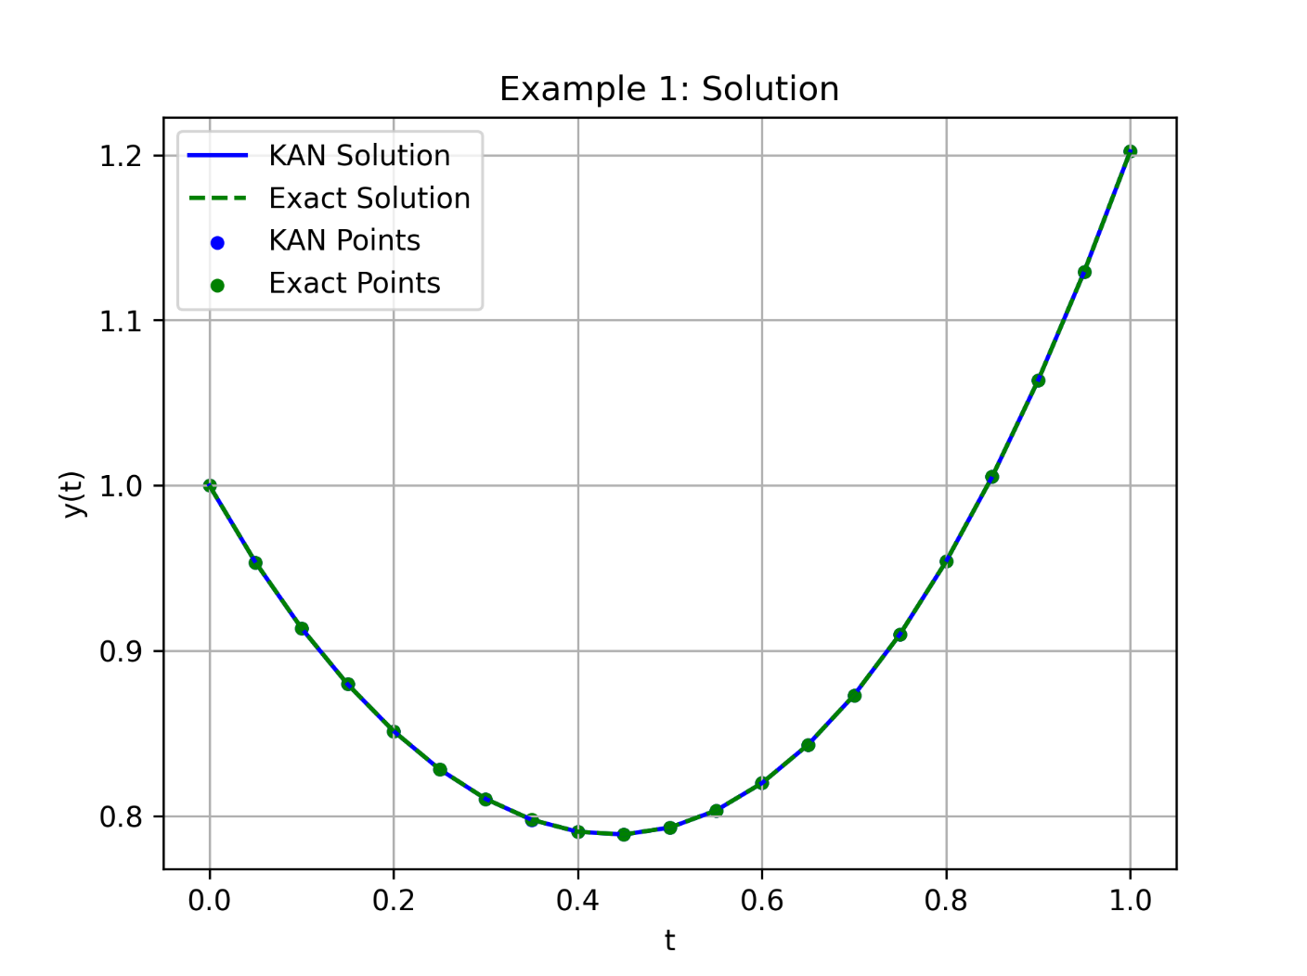 Average MSE 4.6673 x 10-11, Average MAE 1.7985 x 10-6

* + 1. **Example 2**

Consider another first-order linear differential equation:

With the initial condition:

$$y\left(0\right)=3$$

Compared results to other references:

| **x** | **WNNIBOA** | **WNNBOA** | **WNNPSO** | **WNNPSOA** | **WNNMBP** | **WNNDEV** | **KAN** |
| --- | --- | --- | --- | --- | --- | --- | --- |
| 0.0000 | 0 | 0 | 0 | 0 | 0 | 0 | 0 |
| 0.1500 | 1.94e-07 | 3.83e-01 | 4.26e-03 | 3.96e-03 | 6.06e-03 | 2.06e-01 | 1.02e-04 |
| 0.3000 | 1.14e-07 | 4.91e-01 | 8.61e-03 | 8.60e-03 | 1.37e-02 | 2.78e-01 | 7.78e-05 |
| 0.4500 | 9.81e-08 | 4.55e-01 | 4.31e-03 | 4.78e-03 | 8.48e-03 | 9.93e-02 | 6.29e-05 |
| 0.6000 | 6.96e-08 | 3.72e-01 | 1.37e-03 | 7.14e-04 | 7.51e-04 | 3.56e-02 | 4.82e-05 |
| 0.7500 | 4.66e-08 | 3.07e-01 | 2.33e-03 | 2.00e-03 | 4.37e-03 | 3.90e-02 | 4.25e-05 |
| 0.9000 | 3.22e-08 | 2.89e-01 | 8.68e-04 | 4.93e-04 | 1.09e-03 | 2.33e-01 | 3.53e-05 |
| 1.0500 | 2.35e-08 | 3.18e-01 | 3.74e-03 | 2.90e-03 | 4.05e-03 | 3.49e-01 | 9.93e-06 |
| 1.2000 | 2.71e-08 | 3.74e-01 | 3.21e-03 | 2.65e-03 | 5.86e-03 | 2.80e-01 | 8.43e-06 |
| 1.3500 | 3.27e-08 | 4.27e-01 | 1.09e-04 | 4.75e-04 | 3.18e-03 | 8.31e-02 | 6.32e-05 |
| 1.5000 | 3.05e-08 | 4.48e-01 | 2.34e-03 | 1.22e-03 | 1.17e-03 | 8.79e-02 | 3.67e-05 |
| 1.6500 | 2.46e-08 | 4.20e-01 | 1.94e-03 | 1.06e-03 | 3.50e-03 | 1.25e-01 | 6.43e-06 |
| 1.8000 | 1.66e-08 | 3.48e-01 | 4.95e-04 | 2.19e-04 | 2.37e-03 | 4.67e-02 | 8.22e-06 |
| 1.9500 | 5.45e-09 | 2.54e-01 | 2.22e-03 | 1.01e-03 | 7.16e-04 | 3.59e-02 | 4.58e-06 |
| 2.1000 | 4.24e-10 | 1.74e-01 | 1.46e-03 | 6.39e-04 | 2.95e-03 | 2.95e-02 | 4.70e-06 |
| 2.2500 | 1.37e-09 | 1.42e-01 | 7.81e-04 | 1.47e-04 | 2.55e-03 | 5.14e-02 | 1.03e-05 |
| 2.4000 | 1.17e-08 | 1.87e-01 | 1.78e-03 | 3.94e-04 | 2.58e-05 | 1.04e-01 | 1.67e-05 |
| 2.5500 | 1.30e-08 | 3.23e-01 | 2.82e-04 | 1.18e-04 | 2.30e-03 | 5.27e-02 | 2.37e-05 |
| 2.7000 | 2.57e-09 | 5.54e-01 | 1.53e-03 | 8.06e-06 | 2.05e-03 | 4.40e-02 | 6.30e-06 |
| 2.8500 | 2.61e-08 | 8.80e-01 | 4.11e-04 | 3.69e-05 | 9.74e-04 | 5.01e-02 | 1.83e-06 |
| 3.0000 | 9.59e-08 | 1.31e+00 | 1.45e-03 | 1.24e-04 | 2.23e-03 | 2.43e-03 | 9.76e-05 |

| **x** | **Exact Solution** | **RBFNet Rizaner (n=21)** | **RBFNN (n=21)** | **RBFNN (n=90)** | **KAN** |
| --- | --- | --- | --- | --- | --- |
| 0.00 | 3.0000 | 3.0000 | 3.0000 | 3.0000 | 3.000 |
| 0.15 | 2.3438 | 2.2435 | 2.3438 | 2.3438 | 2.3437 |
| 0.30 | 1.8142 | 1.8138 | 1.8142 | 1.8142 | 1.8141 |
| 0.45 | 1.3511 | 1.3510 | 1.3511 | 1.3511 | 1.3511 |
| 0.60 | 0.9348 | 0.9344 | 0.9348 | 0.9348 | 0.9347 |
| 0.75 | 0.5763 | 0.5752 | 0.5763 | 0.5763 | 0.5762 |
| 0.90 | 0.3012 | 0.2998 | 0.3012 | 0.3012 | 0.3011 |
| 1.05 | 0.1318 | 0.1308 | 0.1318 | 0.1318 | 0.1317 |
| 1.20 | 0.0726 | 0.0720 | 0.0726 | 0.0726 | 0.0725 |
| 1.35 | 0.1038 | 0.1030 | 0.1038 | 0.1038 | 0.1038 |
| 1.50 | 0.1845 | 0.1834 | 0.1845 | 0.1845 | 0.1844 |
| 1.65 | 0.2643 | 0.2632 | 0.2643 | 0.2643 | 0.2642 |
| 1.80 | 0.2988 | 0.2982 | 0.2988 | 0.2988 | 0.2988 |
| 1.95 | 0.2638 | 0.2637 | 0.2638 | 0.2638 | 0.2638 |
| 2.10 | 0.1625 | 0.1622 | 0.1625 | 0.1625 | 0.1624 |
| 2.25 | 0.0235 | 0.02227 | 0.0235 | 0.0235 | 0.0235 |
| 2.40 | -0.1095 | -0.1107 | -0.1095 | -0.1095 | -0.1094 |
| 2.55 | -0.1937 | -0.1952 | -0.1937 | -0.1937 | -0.1936 |
| 2.70 | -0.2025 | -0.2043 | -0.2025 | -0.2025 | -0.2025 |
| 2.85 | -0.1348 | -0.1373 | -0.1348 | -0.1348 | -0.1348 |
| 3.00 | -0.0157 | -0.0186 | -0.0157 | -0.0157 | -0.0156 |
| **Error** | 0 | 1.44e-06 | 5.85e-12 | 9.95e-13 | 2.10e-10 |

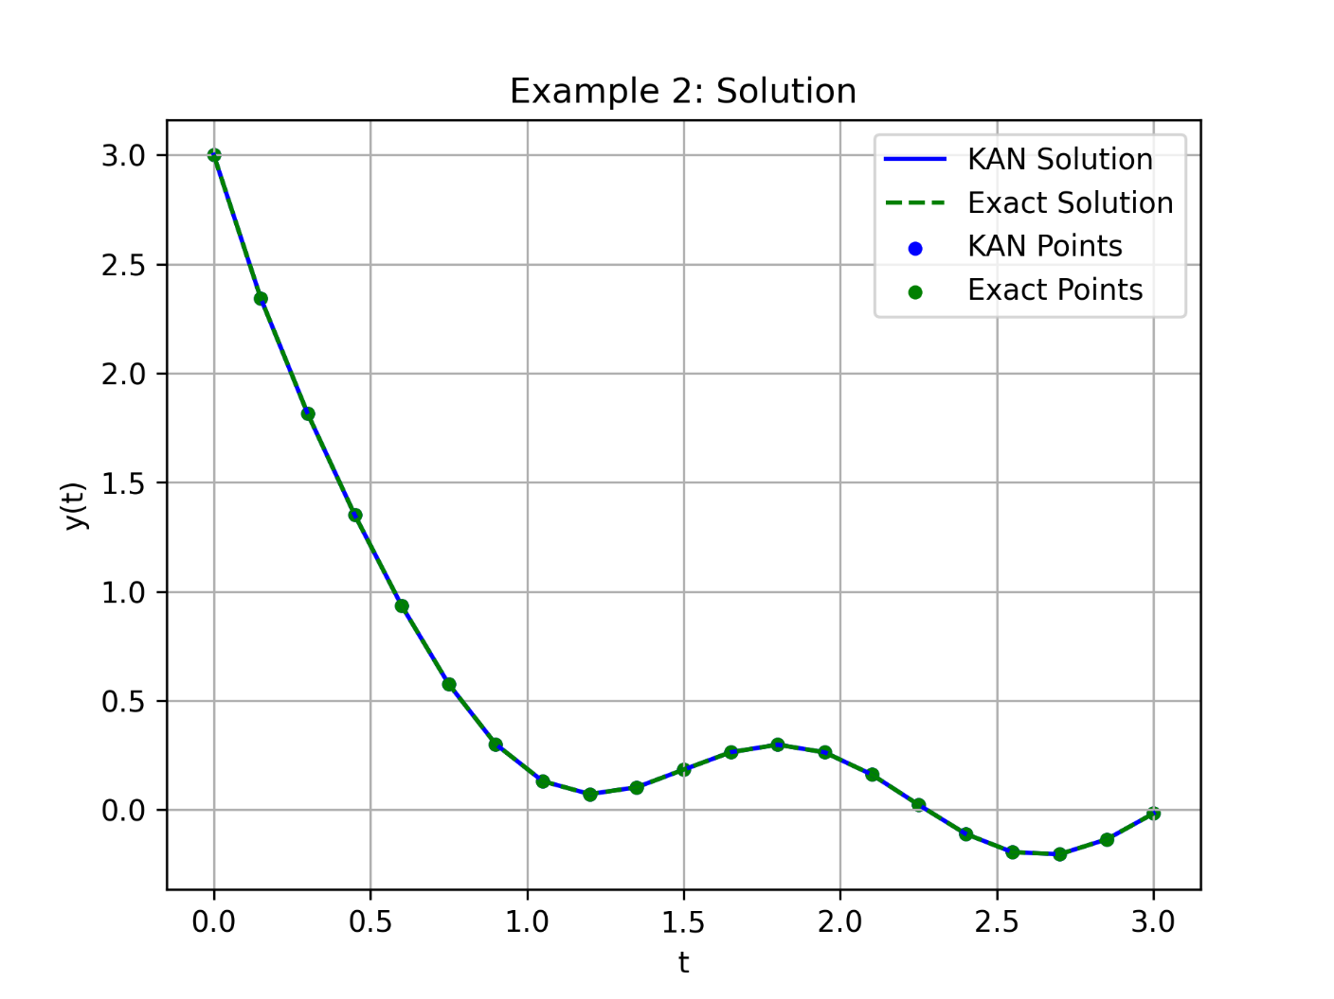 Average MSE 2.1085 x 10-10, Average MAE 3.3426 x 10-6

* + 1. **Example 3**

Consider another first-order linear differential equation:

With the initial condition:

$$y\left(0\right)=0.5$$

Compared results to other references:

| **x** | **WNNIBOA** | **WNNBOA** | **WNNPSO** | **WNNPSOA** | **WNNMBP** | **WNNDEV** | **KAN** |
| --- | --- | --- | --- | --- | --- | --- | --- |
| 0.0000 | 0 | 0 | 0 | 0 | 0 | 0 | 0 |
| 0.2000 | 3.72e-09 | 1.54e-01 | 5.05e-05 | 1.64e-04 | 4.73e-04 | 1.01e-02 | 7.96e-05 |
| 0.4000 | 2.29e-09 | 2.94e-01 | 9.97e-05 | 2.15e-04 | 7.12e-04 | 3.50e-03 | 6.03e-05 |
| 0.6000 | 6.12e-09 | 4.22e-01 | 6.67e-06 | 9.45e-05 | 4.75e-04 | 7.78e-03 | 4.17e-05 |
| 0.8000 | 9.51e-09 | 5.28e-01 | 1.88e-04 | 2.53e-04 | 4.12e-04 | 1.36e-02 | 1.74e-05 |
| 1.0000 | 9.65e-09 | 6.06e-01 | 6.65e-05 | 6.29e-05 | 7.53e-04 | 8.46e-03 | 3.57e-06 |
| 1.2000 | 1.42e-08 | 6.68e-01 | 1.54e-04 | 4.41e-04 | 1.18e-03 | 8.34e-04 | 9.05e-06 |
| 1.4000 | 1.23e-08 | 7.37e-01 | 5.09e-05 | 2.93e-04 | 1.28e-03 | 5.92e-03 | 2.47e-05 |
| 1.6000 | 3.07e-08 | 8.32e-01 | 2.23e-04 | 1.78e-04 | 1.17e-03 | 1.06e-02 | 2.24e-05 |
| 1.8000 | 1.52e-08 | 9.65e-01 | 1.41e-04 | 1.18e-06 | 1.57e-03 | 1.20e-02 | 4.67e-05 |
| 2.0000 | 3.51e-07 | 1.14e+00 | 3.48e-05 | 6.41e-04 | 2.47e-03 | 1.51e-02 | 2.07e-04 |

Average MSE 4.8837 x 10-10, Average MAE 4.8980 x 10-6

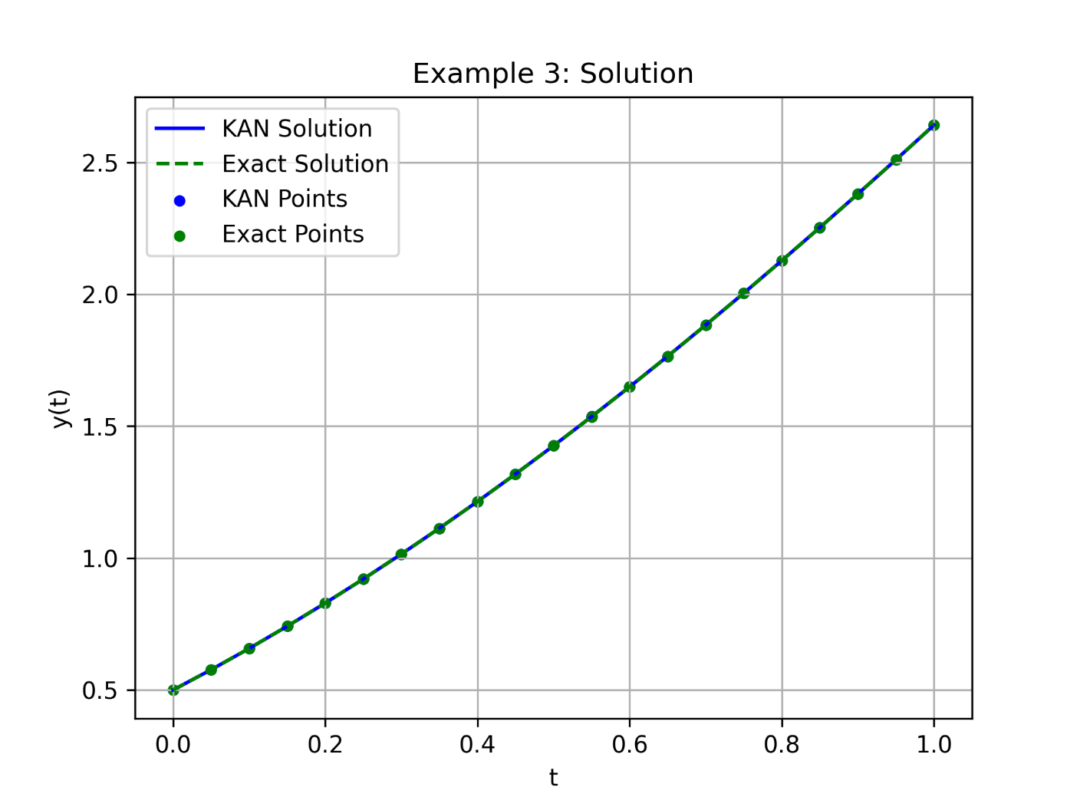

1. **Conclusion**

**WRITE THIS AND ABSTRACT IN THE END**

**Acknowledgements (if there are any)**

**References (APA for now unless we decide to change it.)**

1. Tan, L. S., Zainuddin, Z., Ong, P., & Abdullah, F. A. (2024). An effective wavelet neural network approach for solving first and second order ordinary differential equations. *Applied Soft Computing*, *154*, 111328.
2. Liu, M., Peng, W., Hou, M., & Tian, Z. (2023). Radial basis function neural network with extreme learning machine algorithm for solving ordinary differential equations. *Soft Computing*, *27*(7), 3955-3964.
3. Rizaner, F. B., & Rizaner, A. (2018). Approximate solutions of initial value problems for ordinary differential equations using radial basis function networks. *Neural Processing Letters*, *48*, 1063-1071.
4. Dwivedi, V., & Srinivasan, B. (2020). Physics informed extreme learning machine (pielm)–a rapid method for the numerical solution of partial differential equations. *Neurocomputing*, *391*, 96-118.
5. Li, S., & Wang, X. (2021). Solving ordinary differential equations using an optimization technique based on training improved artificial neural networks. *Soft Computing*, *25*(5), 3713-3723.
6. Kich, V. A., Bottega, J. A., Steinmetz, R., Grando, R. B., Yorozu, A., & Ohya, A. (2024, October). Kolmogorov-Arnold Networks for Online Reinforcement Learning. In *2024 24th International Conference on Control, Automation and Systems (ICCAS)* (pp. 958-963). IEEE.
7. Yu, T., Qiu, J., Yang, J., & Oseledets, I. (2024). Sinc kolmogorov-arnold network and its applications on physics-informed neural networks. *arXiv preprint arXiv:2410.04096*.
8. Jahin, M. A., Masud, M. A., Mridha, M. F., Aung, Z., & Dey, N. (2024). Kacq-dcnn: Uncertainty-aware interpretable kolmogorov-arnold classical-quantum dual-channel neural network for heart disease detection. *arXiv preprint arXiv:2410.07446*.
9. Liu, F., Viano, L., & Cevher, V. (2022). Understanding deep neural function approximation in reinforcement learning via $\epsilon $-greedy exploration. *Advances in Neural Information Processing Systems*, *35*, 5093-5108.
10. Heinlein, A., Klawonn, A., Lanser, M., & Weber, J. (2021). Combining machine learning and domain decomposition methods for the solution of partial differential equations—A review. *GAMM‐Mitteilungen*, *44*(1), e202100001.
11. Goswami, S., Kontolati, K., Shields, M. D., & Karniadakis, G. E. (2022). Deep transfer operator learning for partial differential equations under conditional shift. *Nature Machine Intelligence*, *4*(12), 1155-1164.
12. Soleymani, F., & Zhu, S. (2021). RBF-FD solution for a financial partial-integro differential equation utilizing the generalized multiquadric function. *Computers & Mathematics with Applications*, *82*, 161-178.
13. Koenig, B. C., Kim, S., & Deng, S. (2024). KAN-ODEs: Kolmogorov–Arnold network ordinary differential equations for learning dynamical systems and hidden physics. *Computer Methods in Applied Mechanics and Engineering*, *432*, 117397.
14. Chen, Y., Yu, H., Meng, X., Xie, X., Hou, M., & Chevallier, J. (2021). Numerical solving of the generalized Black-Scholes differential equation using Laguerre neural network. *Digital Signal Processing*, *112*, 103003.
15. Selitskiy, S. (2022). Kolmogorov's Gate Non-linearity as a Step toward Much Smaller Artificial Neural Networks. In *ICEIS (1)* (pp. 492-499).
16. van Deventer, H., van Rensburg, P. J., & Bosman, A. (2022). KASAM: Spline Additive Models for Function Approximation. *arXiv preprint arXiv:2205.06376*.
17. Shukla, K., Toscano, J. D., Wang, Z., Zou, Z., & Karniadakis, G. E. (2024). A comprehensive and FAIR comparison between MLP and KAN representations for differential equations and operator networks. *arXiv preprint arXiv:2406.02917*.
18. Liu, Z., Wang, Y., Vaidya, S., Ruehle, F., Halverson, J., Soljačić, M., Hou, T.Y. & Tegmark, M. (2024). Kan: Kolmogorov-arnold networks. *arXiv preprint arXiv:*